Correlations with new cases deaths and vaccination

In this section, we will incorporate vaccination and COVID-19 death data to explore potential correlations with aviation-related variables. By examining these correlations, we aim to uncover insights into how the pandemic and vaccination efforts have impacted aviation activities. First, we calculate the correlation coefficient between each variable and the number of deaths as well as the number of vaccinations and new cases. The variables analyzed are as follows: local flights, cross-country flights, total passengers, total cargo, and total mail. These coefficients indicate the strength and direction of the linear relationship between each variable and the number of deaths as well as the number of vaccinations.

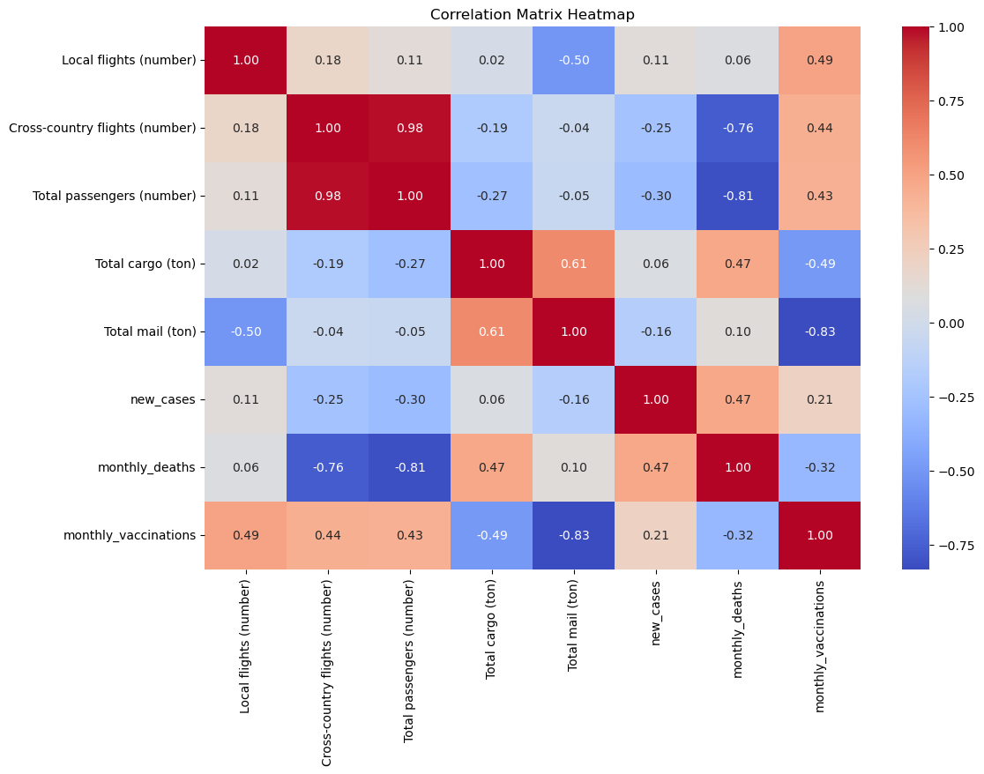

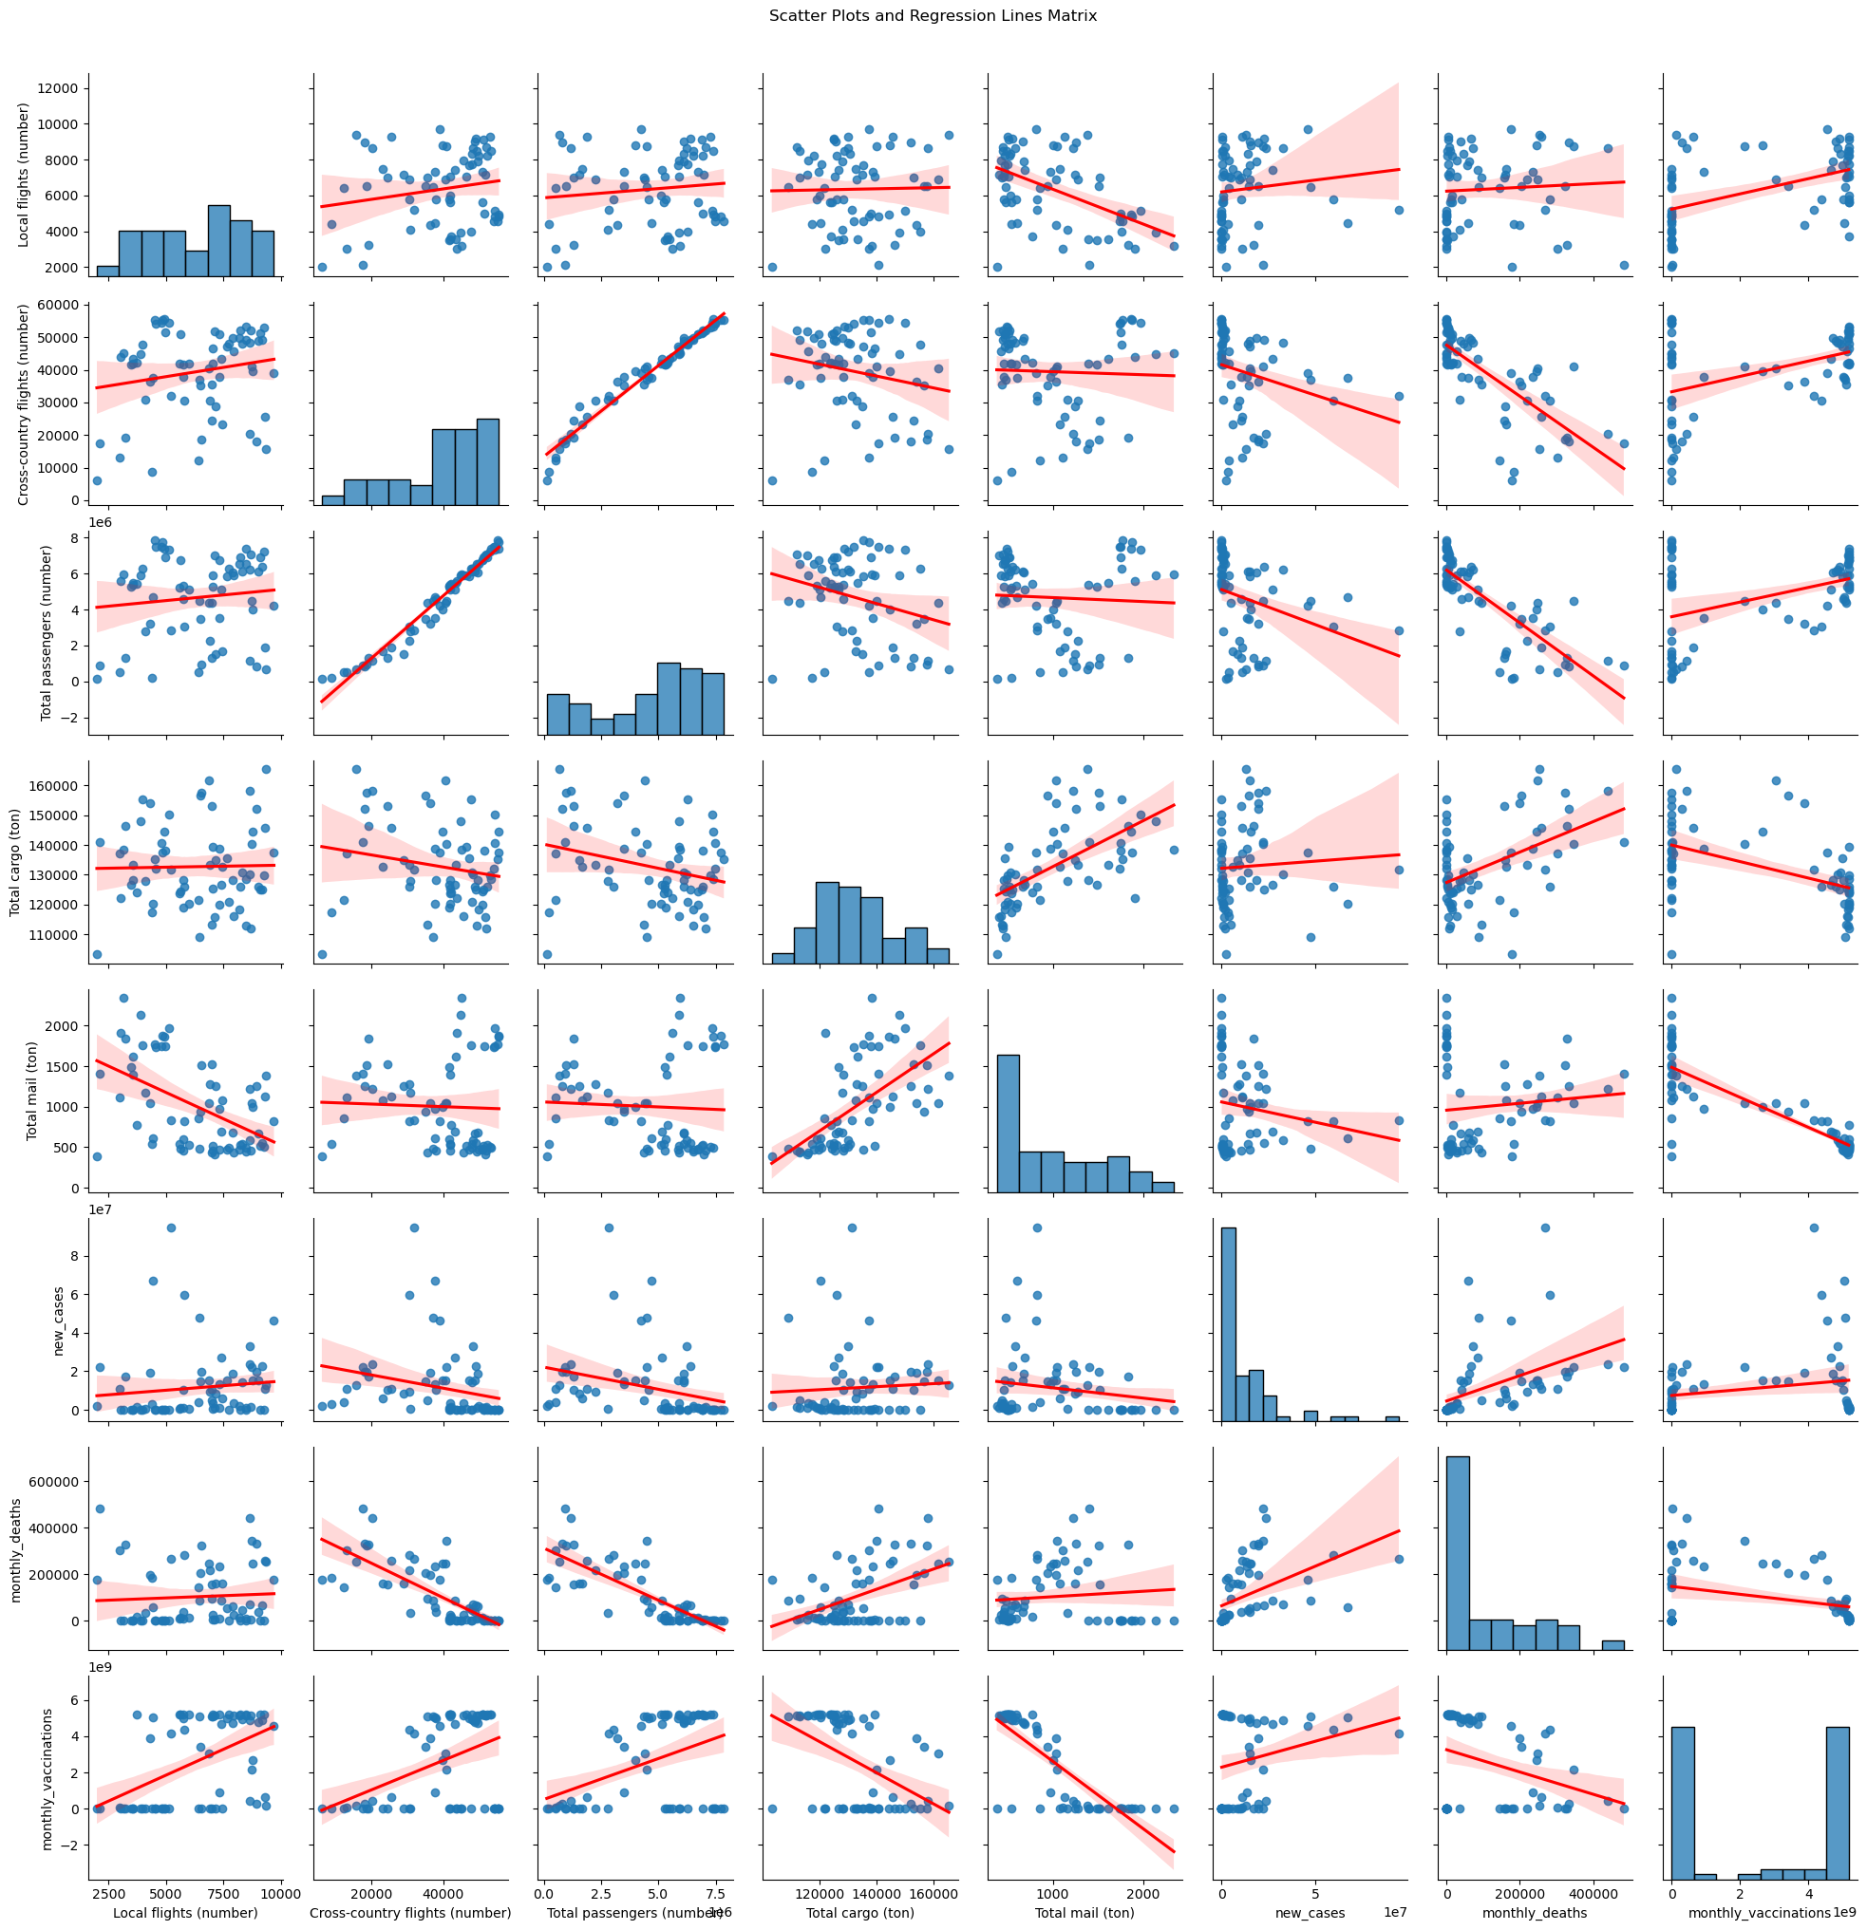

The plots clearly reveal a linear correlation between COVID-related data and aviation activity indicators. New case numbers appear to have minimal impact on aviation indicators, as reflected by the low correlation coefficients. In contrast, monthly death data show a stronger correlation with specific indicators, such as total cargo. Similarly, monthly vaccination data are closely related to local flights, cross-country flights, and total passenger numbers, which is expected given the direct influence of vaccination rates on passenger travel. While the correlation analysis provides valuable insights for developing a linear regression model, the results are less than ideal, suggesting the need to explore alternative predictive models.